



PARLIAMENTARY PROCEDURE CONCEPTS
~TEAM~
(550)
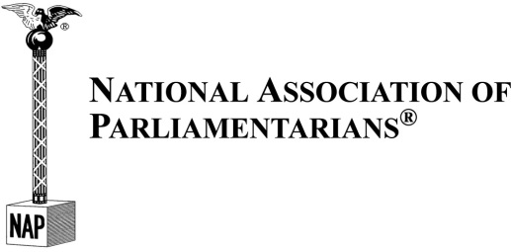
NATIONAL 2021

TOTAL POINTS ____________100 Points

Test Time: 60 minutes

Questions are taken from Dunbar’s Manual of Parliamentary Procedure Test Questions (Fourth Edition, 18th Printing) as prescribed by the Workplace Skills Assessment Program guidelines for this event.

1 | B |  | 26 | C
2 | C |  | 27 | B
3 | C |  | 28 | C
4 | A |  | 29 | C
5 | C |  | 30 | D
6 | C |  | 31 | A
7 | B |  | 32 | B
8 | D |  | 33 | B
9 | B |  | 34 | A
10 | C |  | 35 | B
11 | C |  | 36 | D
12 | B |  | 37 | A
13 | A |  | 38 | C
14 | D |  | 39 | D
15 | B |  | 40 | B
16 | C |  | 41 | B
17 | B |  | 42 | C
18 | B |  | 43 | D
19 | B |  | 44 | C
20 | D |  | 45 | C
21 | B |  | 46 | A
22 | C |  | 47 | C
23 | C |  | 48 | B
24 | D |  | 49 | C
25 | B |  | 50 | D

